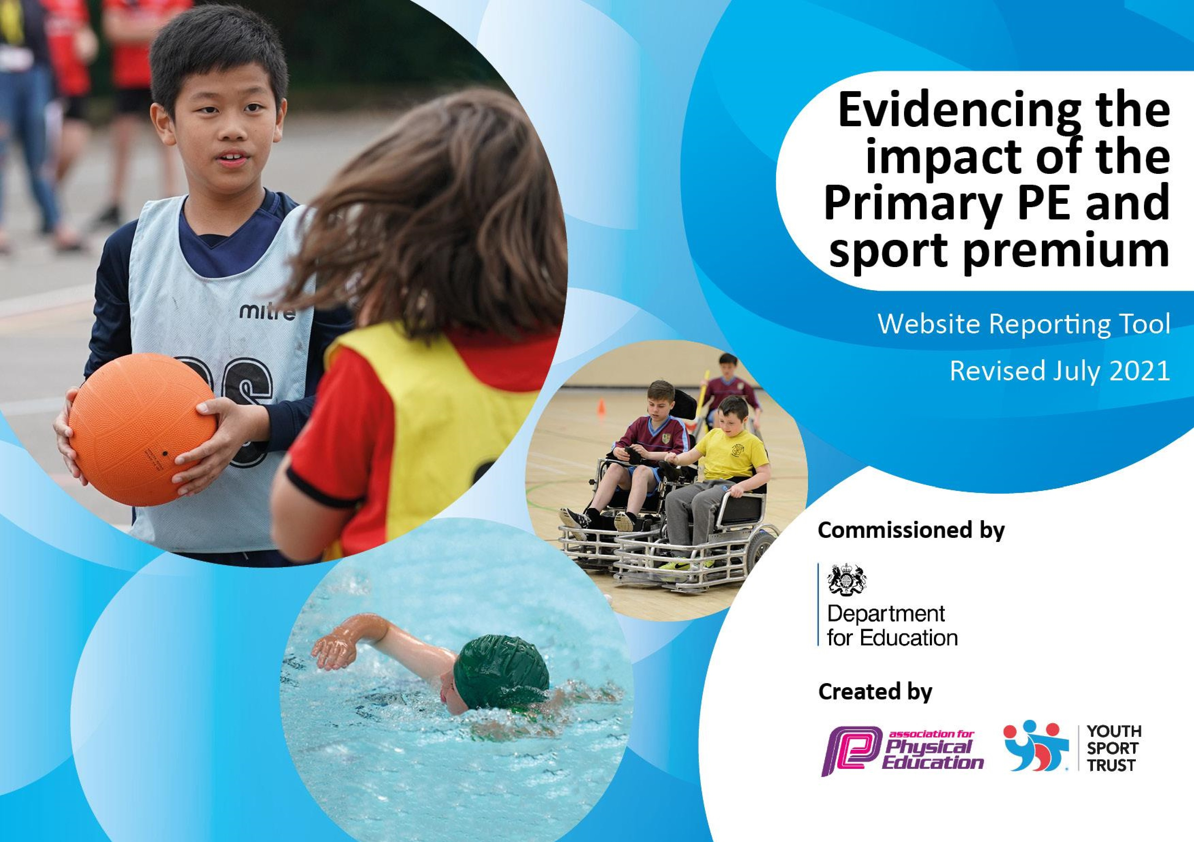

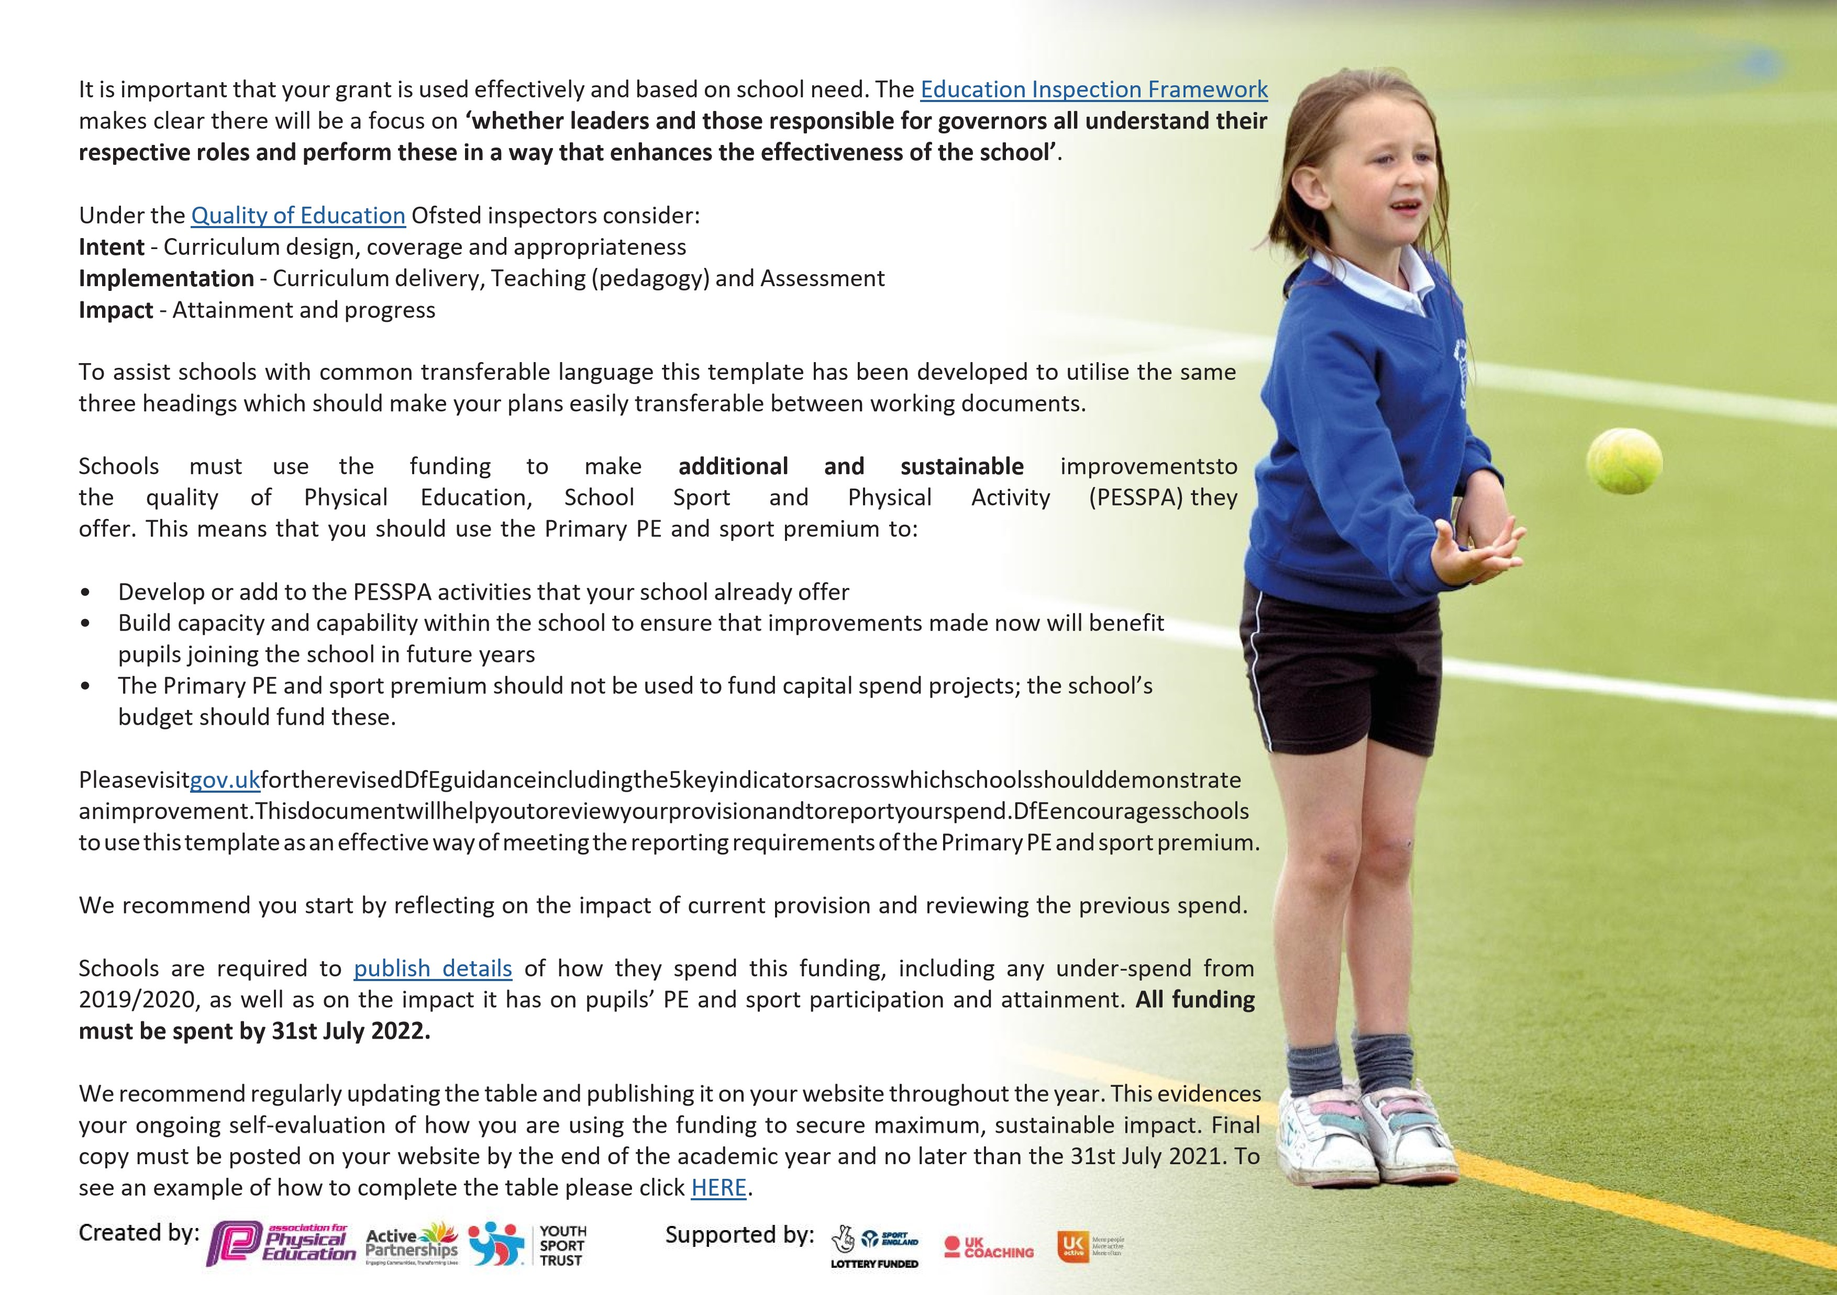



**Details**

**with**

**regard**

**to**

**funding**

Please

complete

the

table

below.

|  |  |
| --- | --- |
| Total amount carried over from 2021/22 | £ 0 |
| Total amount allocated for 2021/22 | £16920 |
| How much (if any) do you intend to carry over from this total fund into 2022/23 | £0 |
| Total amount allocated for 2022/23 | £16860 |
| Total amount of funding for 2022/23. To be spent and reported on by 31st July 2023 | £16860 |



**Swimming**

**Data**

Please

report

on

your

Swimming

Data

below.

|  |  |
| --- | --- |
| Meeting national curriculum requirements for swimming and water safety.    N.B. Complete this section to your best ability. For example you might have practised safe self-rescue techniques on dry land which you can then transfer to the pool when school swimming restarts.  **Due to exceptional circumstances priority should be given to ensuring that pupils can perform safe self rescue even if they do not fully meet the first two requirements of the NC programme of study** |  |
| What percentage of your current Year 6 cohort swim competently, confidently and proficiently over a distance of at least 25 metres?  **N.B.** Even though your pupils may swim in another year please report on their attainment on leaving primary school at the end of the summer term 2023. Please see note above | 42% |
| What percentage of your current Year 6 cohort use a range of strokes effectively [for example, front crawl, backstroke and breaststroke]? Please see note above | 42% |
| **What percentage of your current Year 6 cohort perform safe self-rescue in different water-based situations?** | 42% |
| Schools can choose to use the Primary PE and sport premium to provide additional provision for swimming but this must be for activity **over and above** the national curriculum requirements. Have you used it in this way? | No |

**Action Plan and Budget Tracking**

Capture your intended annual spend against the 5 key indicators. Clarify the success criteria and evidence of impact that you intend to measure to evaluate for pupils today and for the future.



|  |  |  |  |  |
| --- | --- | --- | --- | --- |
| **Academic Year:** 2022/23 | **Total fund allocated: £16860** | **Date Updated: July 2023** | |  |
| **Key indicator 1:** The engagement of all pupils in regular physical activity – Chief Medical Officers guidelines recommend that primary school pupils undertake at least 30 minutes of physical activity a day in school | | | | Percentage of total allocation: |
| 43% |
| **Intent** | **Implementation** | | **Impact** |  |
| All pupils to be engaged in physical activities at playtimes and lunchtimes daily for at least 1 hour per day.      Increase the percentage of pupils participating in a variety of physical activities across the school day | Sports Apprentice employed to organise and oversee daily playground activities for pupils across the school that increase participation and activity of more children.      Renew play resources for each class to use at playtimes. | Funding allocated:    £7,000              £300 | Lunchtime organisation has increased and as such children are now more engaged in physical activity.  A variety of equipment has been purchased in order to encourage children to be more physically active. This includes balance bars, balls and hoops. | Sustainability and suggested next steps:    Plan playground zoning areas. Each area will have an activity, with a member of staff assigned to it. They will lead activities to encourage children to take part.  We will continue to allocate sports premium funding to employing a sports apprentice.    Investing in resources with an annual audit/budget. |
|  |  | **£7300** |  |  |
| **Key indicator 2:** The profile of PESSPA being raised across the school as a tool for whole school improvement | | | | Percentage of total allocation: |
| 47% |
| **Intent** | **Implementation** | | **Impact** |  |
| *Inspire + Core Membership Annual  Subscription      Educate pupils on how positive attitudes to sport can be transferred to all areas of our learning. | Inspire+ Ambassador assemblies to promote healthy active lifestyles. Sam Ruddock, Sophie Devenish, Dai Greene, Joe Roebuck and Jonathan  Broom-Edwards. These are good role models for our children and promote a love of physical activity and mental well-bring. | Funding allocated:    £8000      Included in inspire+ membership. | Sam Ruddock delivered whole school assembly promoting resilience in sport and wider life.    Jonathan Broom-Edwards, Paralympic Champion, delivered a whole school assembly Paralympic with an update on his career and a new focus of resilience to the children.  Dai Greene, world Champion 400m hurdler delivered whole school assembly concentrating o the theme of perseverance. He talked to the children about working hard when faced with adversity. | Sustainability and suggested next steps:      Through Inspire+ access guest speakers and ambassadors to promote positive healthy lifestyles. This will encourage the children within school but also within their home environments. |

|  |  |  |  |  |  |
| --- | --- | --- | --- | --- | --- |
| Children to show an awareness of healthy foods and nutrition. What they need to consume in order to keep a healthy body..            Children to develop own awareness of sports around the commonwealth.          Selected talented athletes to develop leadership skills in sport.  Selected pupils to become Bronze Young Ambassadors | models for the children – linked to low self esteem and less active pupils. Develop opportunities for pupil engagement with PE and sport throughout the school.  Sophie will provide a nutrition workshop, giving pupils the knowledge they need to improve their well being and diet. Work will take place around healthy eating with the aim to encourage a healthy balanced diet.        Participation in the Mini commonwealth games and represent a country.          Children to attend virtually sessions with Inspire+ ambassadors. The program is targeted to those pupils showing high athletic ability to work alongside Olympic and Paralympic athletes in gaining the best mind & skill set to take their sporting success to the next level.  Young Ambassador Programme will allow selected children to lead pupils and the school in a variety of different objectives. They will lead the Legacy Tour assembly, create a sports board promoting sport and physical activity within school and help to lead clubs across school. Training sessions will be given alongside other Bronze Ambassadors within the local area to give them the knowledge and skills to aid the support and delivery of physical activity within school. | Included in inspire+ membership.            Included in inspire+ membership.      Included in membership.  Included in membership. | Sophie delivered a nutrition workshop to give pupils guidance on their healthy choices. It focused on gaining independence with our food intake, taking control of their consumptions, and getting more of an understanding, not only of ‘what’ we put into our bodies, but also ‘why’! The children showed huge enthusiasm for their food choices.  Children in Year 3 and 4 attended the annual Mini Olympics representing Brazil. They took part in a variety of events, broadening their horizons. These included wheelchair games, dance, boxercise, freestyle football and American football. The children had a fantastic time, experiencing a real life Olympic event.  Children in Year 5 & 6 have accessed the Talented Athlete Programme. They focused on team work, communication, confidence, biomechanics and diet and nutrition. The children thoroughly enjoyed these sessions, which allowed them to share their knowledge and learn more about how they can fuel their bodies and minds to become the best athletes they can be.  Bronze Ambassadors have had a very important role within school this year. They have developed their leadership qualities, assisting assemblies, leading assemblies, helping within PE lessons, guiding younger children to lead healthy and active lifestyles. | Continue to attend Mini Olympics, souring transport. This will enable the net cohort of children access to a real life Olympic style event, broadening their horizons of cultures and sports.  Identify children in readiness for the next sessions for talented athlete programme. Consider accessing the session for year1/2 pupils.  Continue to support the Bronze Ambassador programme with the new cohort of year 6 children. Identify possible ambassadors to allow them the opportunity to complete leadership responsibilities, promoting a love of sport, physical activity and mental well-being. | |
|  |  | **£8000** |  |  | |
| **Key indicator 3:** Increased confidence, knowledge and skills of all staff in teaching PE and sport | | | | | Percentage of total allocation: |

|  |  |  |  |  |
| --- | --- | --- | --- | --- |
|  | | | | % 0 |
| **Intent** | **Implementation** | | **Impact** |  |
| Renewal of ‘Get Set 4 PE’ scheme of lessons                        To give children a broader curriculum by accessing CPD for various disciplines. This will increase staff confidence and knowledge and in turn will provide the children with high quality PE lessons.  PE Lead support 2 hours each week via Inspire+ to increase confidence in current staff members and to support apprentice. Refine documentation for PE, engaging with school staff ensuring high quality curriculum is achieved.  Access support through Inspire+  Coaching team teach sessions provided for all teaching staff and apprentice to increase knowledge and aid succession planning for future years.  Access Kaboca survey system | P.E. lead to enable, monitor and evaluate the effectiveness of the P.E. scheme.                  Access CPD through Inspire+  membership. This will increase confidence in staff members and thus impacting directly on the quality of provision for each pupil. CPD planner to be circulated to all staff. Cover where needed for staff to attend courses.    Throughout the academic year a specialist PE lead will provide support to the school. Objectives to include: assisting in the organising of school sport activities and festivals, bronze ambassador training, sports premium spend analysis and review, sports apprentice mentoring and support, curriculum monitoring and review, assessment of pupils, analysis of pupil data, kaboca pupil and staff surveys.  Coaches to deliver team teach sessions throughout the year, alongside teachers and apprentice. This will lead to upskilling of teachers to give them the confidence to teach a high quality curriculum for future years. Use GetSet4PE to aid planning and assessment of all children. Assessment will aid future planning and ensure a progression of knowledge for the children.  Apprentice to create surveys for staff and pupils to gain and understanding of confidence levels within teaching and learning. This will aid future planning for curriculum, lunch time and after school club provision. | Funding allocated:        No cost incurred                          Included in inspire+ membership.  Included in inspire+ membership.            Included in inspire+ membership. | As a school we have continued to utilise the getset4pe scheme pf work. This has allowed the staff to deliver a consistent and fluid curriculum. The children have benefited from a real progression of skills, which is evident throughout lessons and through assessment. This has sat alongside high quality CPD coaching from Inspire+.        Staff have attended a variety of courses this year. These have included Forest School Training where they learned the basics of running a forest school. They learned how to build a fire, how to split wood and made in inspirational campfire snacks. They have cascaded information to other staff members to ensure the children are getting the full benefits of the Forest School.  Two members of staff accessed the National Curriculum Training Programme for primary schools to equip staff with the skills and knowledge to deliver high quality school swimming lessons. Staff will now be able to use this knowledge to assist in the delivery of school swimming lessons. This will improve children’s outcomes from their swimming lessons, giving them the confidence and progression within swimming.      Through targeted PE Lead support the school has been able to continue their successes with PE and School Sport. Through mentoring of an apprentice, the school has seen improvements in opportunities for children within lunchtime, extra curricular opportunities and school competitions and festivals. The curriculum map is now tailored to ensure full coverage of the national curriculum and to meet the needs of the children. It shows progression of skills, allowing the children to build on prior knowledge. This allows the children to know more and remember more. Through pupil data analysis targeted support has been put in place for those children who require it.    Units provided for teach teaching include:  EYFS/Year 1&2 Ball Skills  Year 4&5/ Year 6 Hockey & Dodgeball  EYFS/Year 1&2 Fundamentals and Sending and Receiving.  Year 3&4 Year 4&5 Netball & Tag Rugby  Year 4&5/ Year 6 Dance & Tag Rugby  EYFS Dance  Year 6 Rounders & Cricket  Through coaching of these units, Sports Apprentice, Teachers and Teaching Assistants were able to understand the unit progression and how to lead children to gain the required knowledge. This will boost confidence with teachers to allow them to lead sessions alone.  Staff and pupil surveys have been completed across the school year. Through these results school have been able to identify potential CPD for the next academic year for TAs and staff. Children have identified sports club that they would like to see offered and these will be added onto the programme for next year. | Sustainability and suggested next steps:      Continue to utilise getset4pe within curriculum time. Cascade to all staff the use of geset4pe and maintain assessment on this platform.        Research possible ways of increasing the forest school offer on site. Look into ways of developing the area, possible training and equipment.  Teachers to use training and qualification gained to assist the teaching of school swimming. This will improve the teacher to child ratio which in turn will provide better outcomes for the children in achieving water safety and 25m.  Continue to have PE lead support provided by Inspire+ Through this support areas of forest schools, playground zoning and high quality teaching will provide a stronger platform for PE and physical activity across the school.  Through team teaching the sports apprentice is now equipped to lead and deliver high quality PE lessons next academic year.  Consider CPD for areas not accessed this year including gymnastics and dance.  Continue to use koboca platform to assist in feedback from staff and children in order to maintain high quality PE and physical activity across the school community. |
|  |  | £0 |  |  |

|  |  |  |  |  |
| --- | --- | --- | --- | --- |
|  |  |  |  |  |
| **Key indicator 4:** Broader experience of a range of sports and activities offered to all pupils | | | | Percentage of total allocation: |
| 7% |
| **Intent** | **Implementation** | | **Impact** |  |
| To offer a wider range of sporting activities for all pupils, including SEN, disadvantaged pupils. | Mini Commonwealth Games: Events include Paralympic events to give children insight into different challenges.  Transport for Mini Olympics children          Timetable clubs for football, netball, multi-skills, athletics and cricket and lunchtime games clubs throughout the year.  Purchase equipment to enable high levels of participation for all. | Funding allocated:      Included in inspire+ membership.  £500                    £760 | Children in Year 3 and 4 attended the annual Mini Olympics representing Brazil. They took part in a variety of events including wheelchair games, dance, boxercise, freestyle football and American football. The children had a fantastic time, experiencing a real life Olympic event.  Throughout the year clubs have taken place to allow children access to physical activity. The children have responded well to these and have included; football, multi-skills and netball.  Equipment purchase has allowed school to ensure high quality PE and physical activity across the school. | Sustainability and suggested next steps:    Re-book to attend next years Mini Olympics to allow the new cohort to experience an Olympic style event.  Through using koboca surveys children have highlighted clubs for next year they would be interested in. These include dodgeball and rounders.  Complete a PE audit within the new academic year to highlight any areas where equipment may need to be replaced or sourced. |
|  |  |  |  |  |
|  |  | £1260 |  |  |
| **Key indicator 5:** Increased participation in competitive sport | | | | Percentage of total allocation: |
| % 3 |
| **Intent** | **Implementation** | | **Impact** |  |
| Increase the amount of opportunities for pupils to attend sports competitions and festivals.    Celebrate children’s successes within physical activities. | P.E. Apprentice to coordinate teams of pupils to take part in local school cluster sports competitions throughout the school year. Access events including 5/6 netball league, goalball, 5/6 tag rugby tournament, football league, cross country, 3/4 tag rugby tournament, 5/6 indoor athletics, girls football, year 2 multi-skills, 5/6 cricket, 5/6 rounders, track and field athletics.  Access SW Lincs SGO sports programme, attend events including schools swimming gala  Provide certificates for children to celebrate successes within Sports Day, competitions, festivals as arranged within the Stamford cluster | Funding allocated:  £300 | Events have been attended across the academic year. These include year 3/4 football, year 5/6 football, year 5/6 netball, year 5/6 cricket, ks2 athletics, year 1/2 multi-skills and Diversity Festival. All events have been arranged and facilitated by the sports apprentice with assistance from staff within school. This has allowed many children with in school the opportunity to experience festivals and competitions within the local area. The children have flourished within these events and have enjoyed the opportunities given.    Children have been awarded certificates for events they have taken part in. Often these are handed out within assemblies and shared with the school community across social media and the newsletter. This has given children a platform to recognise their achievements. | Sustainability and suggested next step:    Maintain links within the Stamford cluster schools, assist with the planning for next years schedule.  Consider the SW Lincs SGO buy in opportunity.  Research the School Games Mark for next academic year via the SGO.    Continue with certificates for next academic year to reward children for their achievements. Consider badges/ medals as a further approach to rewarding children. |
|  |  | £300 |  |  |

|  |  |
| --- | --- |
| Signed off by | |
| Head Teacher: | Tina Cox |
| Date: | July 2023 |
| Subject Leader: | Tina Cox |
| Date: | July 2023 |
| Governor: | Joe Randall-Carrick |
| Date: | July 2023 |